Artifact 1 - Art

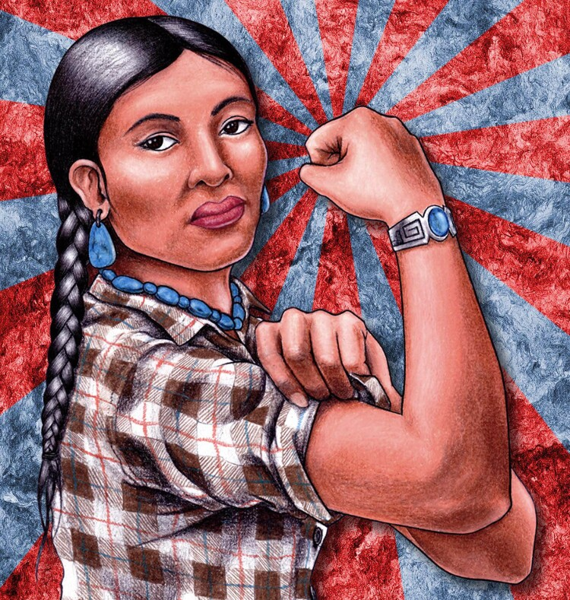
Votan Henriquez, "Warrior Wombyn (aka Rezzie the Riveter)."

Artifact 2 - Literature

The Thanksgiving Cactus by Nathan Spoon

Artifact 3 - Science

https://www.goodnewsnetwork.org/special-toothpaste-could-end-severe-peanut-reactions/

Artifact 4 - Current Events

https://www.engadget.com/sag-aftra-deal-includes-a-40-million-streaming-bonus-and-ai-protections-204526458.html

